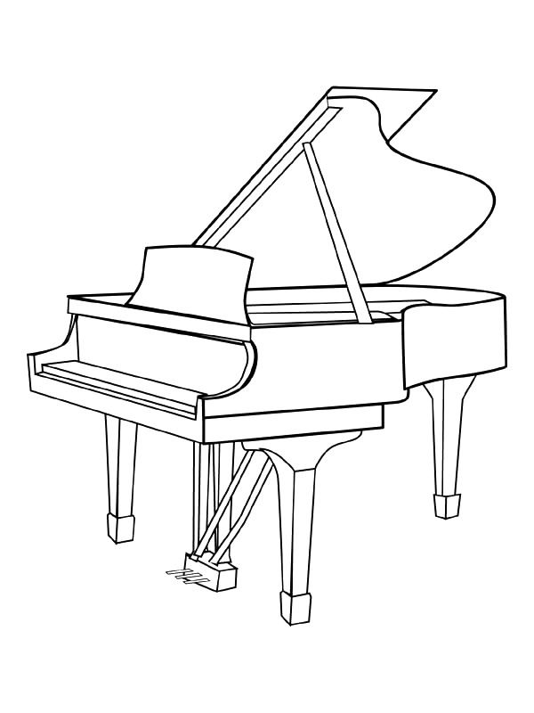
P __ __N __
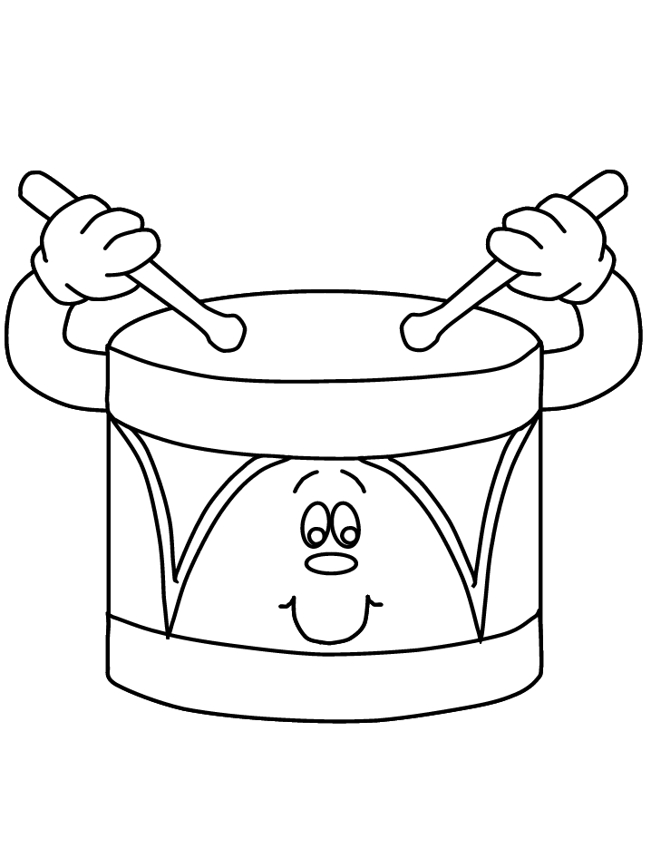

__ R __ M

C __ M __ __ L S
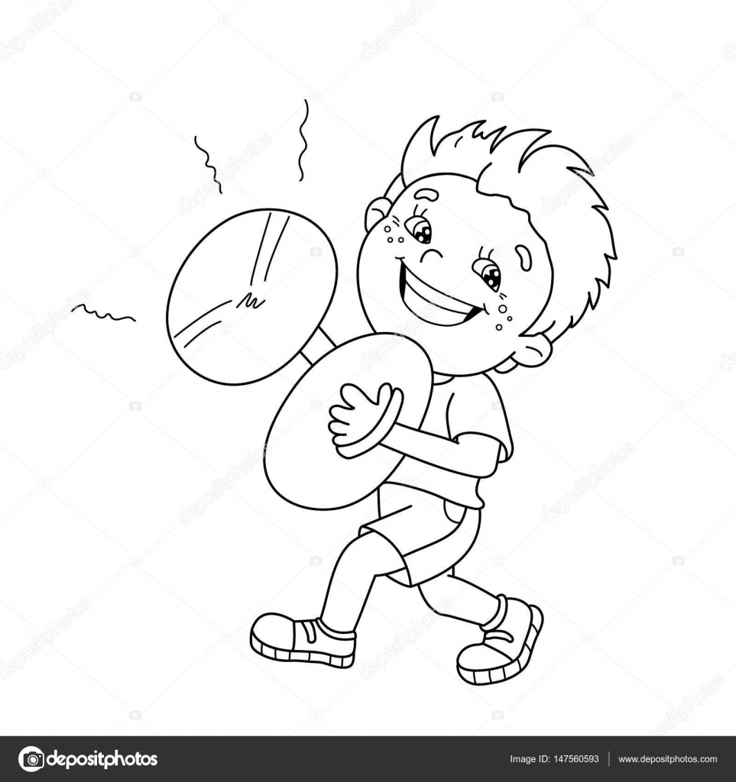

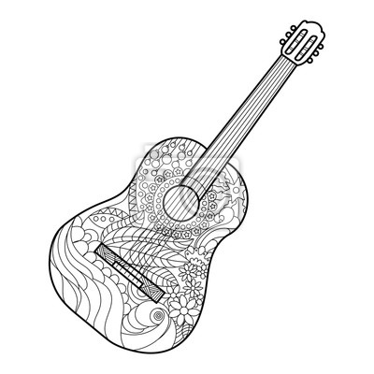

__ U __ T__ __

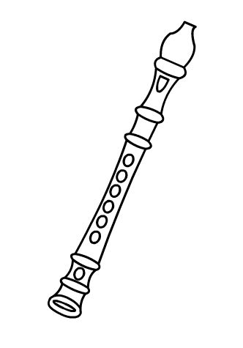

R __ __ O __ __ E __

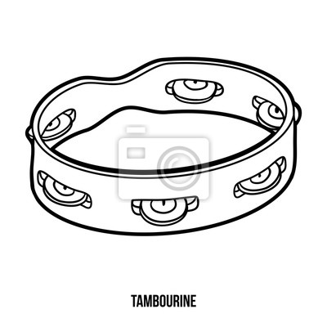
__ A M __ __ U __ I __ E
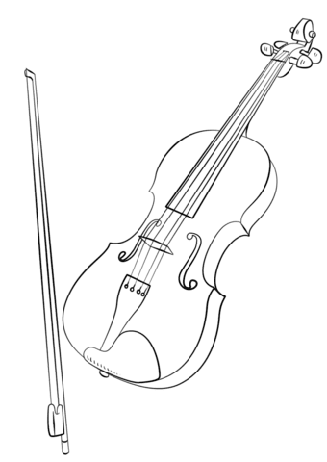

V __ __ L __ N

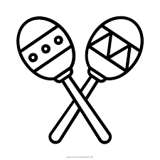
__ A R __ __ A __

- Complete these words

- Answear my questions:
Can you play the piano?
Can you play the tambourine?
Can you play the recorder?
Can you play violin?
Can you play any musical instrument?

- Watch this:
https://www.youtube.com/watch?v=n4gsHAH_q6s 😊

